Lesson plan 4: Logical operators and the REPT function
About the lesson
This lesson introduces students to the use of the logical operators AND and OR. They will learn how to use them within IF functions to check for a range of conditions before returning values. They will also learn how to use the REPT function to repeat a series of characters a specified number of times. They will then apply this learning to practical activities using the spreadsheets provided.
Learning objectives
By the end of this lesson, students will be able to:
- write IF functions using AND and OR to check for a range of conditions
- be able to use the REPT function to repeat a series of characters in a cell
- choose the correct Boolean conditions to use when writing IF functions to check for several conditions.
National Curriculum
The following subject content from the KS3 National Curriculum is included in this lesson:
- Design, use and evaluate computational abstractions that model the state and behaviour of real-world problems and physical systems
- Understand the hardware and software components that make up computer systems
- Understand simple Boolean logic [for example, AND, OR and NOT] and some of its uses in circuits and programming
Links
The use of logical operators links to their use in selection in Scratch and Python programming. The ability to use spreadsheets effectively will be useful across a wide range of other subjects.
Key terminology
logical operator, AND, OR, REPT
Teaching and learning activities
Share the objectives for the lesson with students (Slide 2 of Lesson 4 presentation).
Starter
Explain that, so far, students have used IF functions to check for a single condition (Slide 3 and page 84).
Ask: How do you think we could check for more than one condition?
From their knowledge of programming in Scratch and Python, students may suggest using AND.
Part 1
Demonstrate how to use the logical operator AND within an IF function (Slide 4 and page 84, plus Video 4.1).
Ask students to complete Activity 4.1: Competition (Slide 5, Excel workbook 4, sheet 1/Excel workbook 4.1; Google Sheets workbook 4, sheet 1/Google Sheets workbook 4.1) and Activity 4.2: Maths sets (Slide 6, Excel workbook 4, sheet 2/Excel workbook 4.2; Google Sheets workbook 4, sheet 2/Google Sheets workbook 4.2).
Common misconceptions
Students who are already familiar with the use of logical operators in programming may try to use them between the conditions being checked (=IF(B9>75 AND C9>75)) rather than using the syntax required in spreadsheets (=IF(AND(B9>75,C9>75))
Answers
Activity 4.1
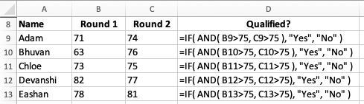
Activity 4.2
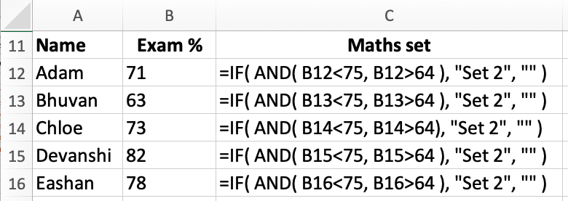
Part 2
Demonstrate how to use the logical operator OR within an IF function (Slide 7 and page 84).
Ask students to complete Activity 4.3: Competition 2 (Slide 8, Excel workbook 4, sheet 3/Excel workbook 4.3; Google Sheets workbook 4, sheet 3/Google Sheets workbook 4.3) and Activity 4.4: Stock levels (Slide 9, Excel workbook 4, sheet 4/Excel workbook 4.4; Google Sheets workbook 4, sheet 4/Google Sheets workbook 4.4).
Answers
Activity 4.3
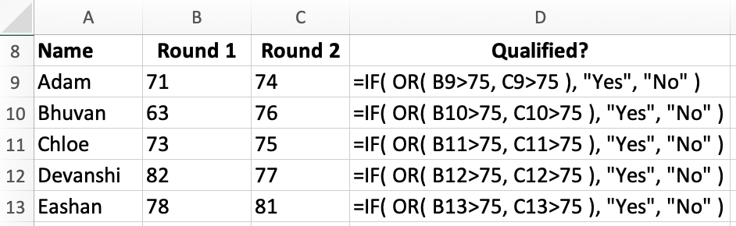
Activity 4.4
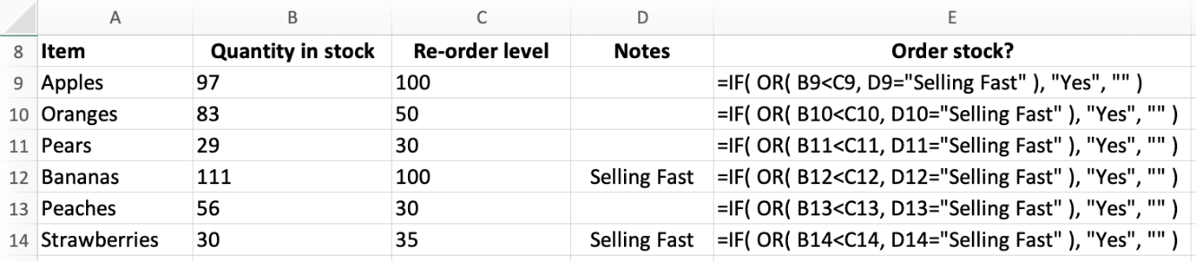
Part 3
Demonstrate how to use the REPT function (Slide 10 and page 85, plus Video 4.2).
Ask students to complete Activity 4.5: Homework (Slide 11, Excel workbook 4, sheet 5/Excel workbook 4.5; Google Sheets workbook 4, sheet 5/Google Sheets workbook 4.5).
Answers
- Check that the correct function has been used in H11 and replicated:
=COUNTIF( B11:G11, "L" )
- Check that the correction function has been used in I11 and replicated:
=REPT( "X", H11 )
- Check that the correct function has been used in J11 and replicated:
=IF( AND( C11="L", E11="L", G11="L" ), "Yes", "" )
Plenary
Check students' knowledge and understanding with a short question and answer session linked to the learning objectives for the lesson.
- Which logical operator would you use to check that at least one condition is true with an IF function?
(Answer: OR)
- Which logical operator would you use to check that several conditions are all true? (Answer: AND)
- Which function would you use to repeat a string a set number of times in another cell? (Answer: The REPT (repeat) function.)
- Do you know another way to repeat a string of text in another cell?
(Answer: Use the concatenate function. Note that students are not expected to know this, but some may be familiar with the concept and the word 'concatenate' from their experience with programming.)
Homework
Ask students to complete any activities they did not finish during the lesson.
Ask students to complete Quiz 4 (Slide 12).
Stretch activities
Students who complete the activities in this lesson quickly could be encouraged to experiment with using NOT in and IF function, for example, =IF(NOT(B2>60),”Fail”,”Pass”), and with combining more than one logical operator in an IF function.
Support activities
Some students may need support in using the correct syntax when writing IF functions. Encourage them to plan out their function on paper, deciding which logical operator to use, then which comparisons need to be made, and finally the outputs for True and False. It may be helpful to provide them with a skeleton framework on paper for the function that they can complete before entering it into the spreadsheet.
A number of short and informative videos can be found online that demonstrate the use of logical operators in spreadsheets such as https://support.microsoft.com/en-us/office/video-if-with-and-and-or-2a47066d-85d8-4751-a59d-3c69d2931c3e and the REPT function such as: https://www.youtube.com/shorts/wCllouOJe-Q

